**Working Document: <Text>**

***Machine Learning Mastery | Arthurlot Li***

**I. Description**

This is a working document meant to serve as a companion to written notes generated while solving a particular machine learning problem. All items listed in this document are to be indexed in a standardized manner for easy reference within the written notes. Retain this document and its contents for future use in the generation of a formal report.

**II. Items**

Refer to each numbered item as **working-#** in written notes(“the box plot seen in *working-5* shows...”)

1. 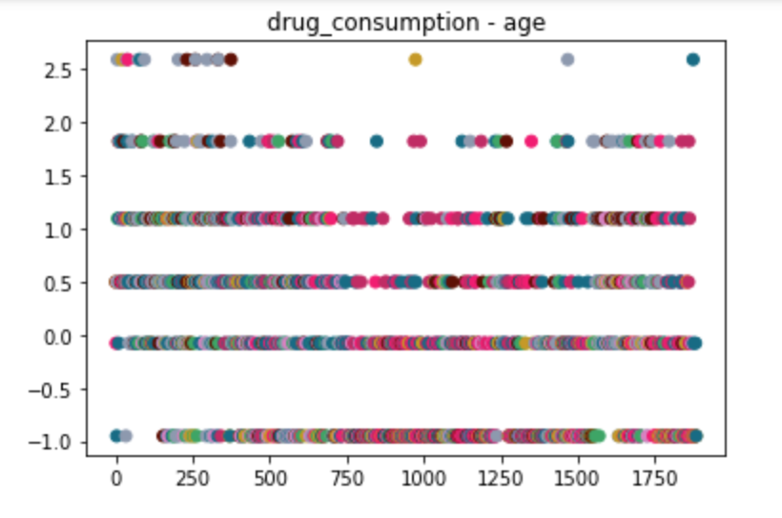
2. Text

   Description automatically generated
3. 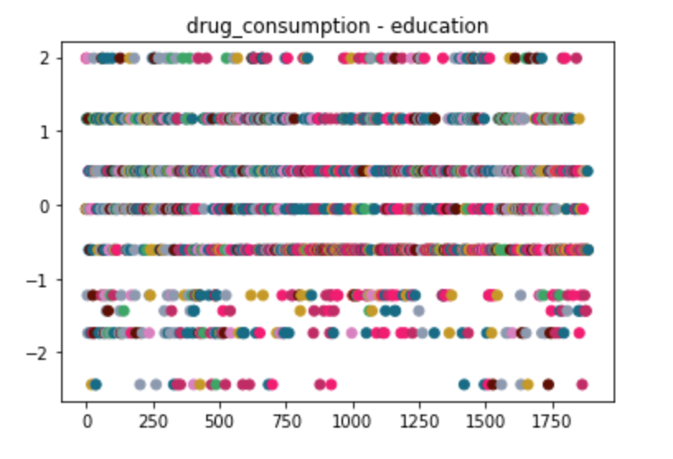
4. Chart

   Description automatically generated with medium confidence
5. Chart, scatter chart

   Description automatically generated
6. Chart, scatter chart

   Description automatically generated
7. 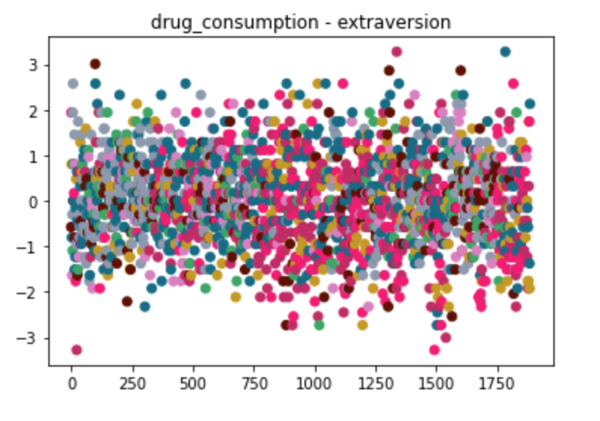
8. 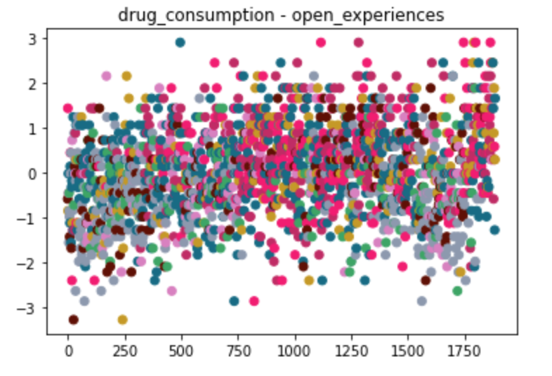
9. 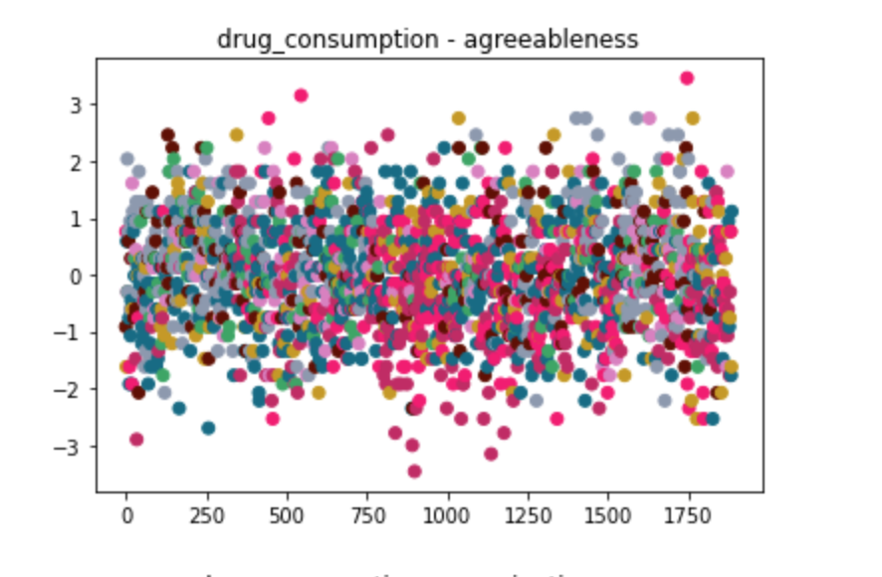
10. 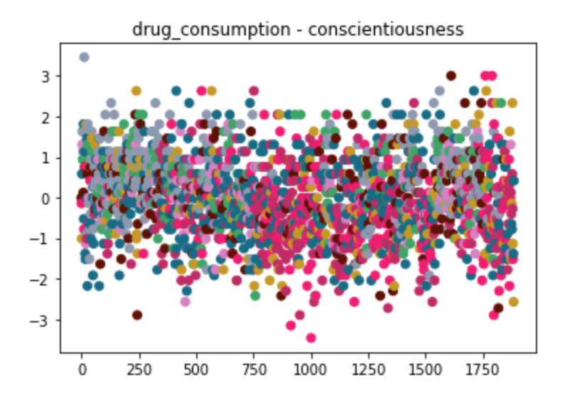
11. Chart

    Description automatically generated with medium confidence
12. A picture containing chart

    Description automatically generated
13. A picture containing application

    Description automatically generated
14. Graphical user interface, application

    Description automatically generated
15. Chart, bar chart

    Description automatically generated
16. Chart

    Description automatically generated
17. Chart, bar chart

    Description automatically generated
18. Chart

    Description automatically generated
19. Chart

    Description automatically generated
20. Chart, line chart

    Description automatically generated

The following graphs are from dataset 4 – HARD DRUGS IN THE LAST WEEK.

1. Diagram

   Description automatically generated
2. Text

   Description automatically generated
3. Diagram

   Description automatically generated with medium confidence
4. Text, chat or text message

   Description automatically generated
5. Chart, diagram

   Description automatically generated
6. Chart, scatter chart

   Description automatically generated
7. Chart, scatter chart

   Description automatically generated
8. Chart, scatter chart

   Description automatically generated
9. Chart, scatter chart

   Description automatically generated
10. Chart, scatter chart

    Description automatically generated
11. A picture containing chart

    Description automatically generated
12. Chart

    Description automatically generated
13. Text

    Description automatically generated with medium confidence
14. A screenshot of a computer

    Description automatically generated with medium confidenceTable

    Description automatically generatedA screenshot of a computer

    Description automatically generated with medium confidenceChart

    Description automatically generatedTable

    Description automatically generated with medium confidenceTable

    Description automatically generated